Sonarqube Server Configuration

Requirements

* Java JDK

Install Java jdk and configure in your system environments variables.

Right click on my computer select properties and choose advanced tab.

Select bottom environment variable and edit the path variable and paste java jdk path. It will differ the screen based on operating system.

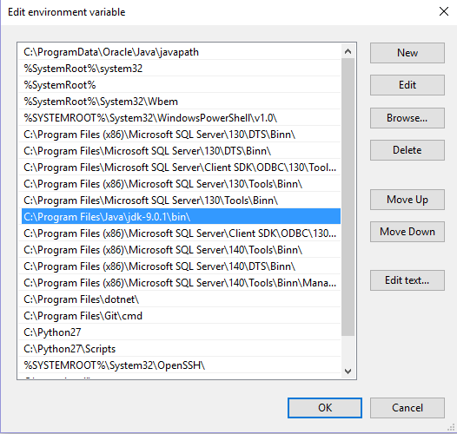.

Step 1 : unzip sonarqube 7.2.1 zip file in to your local directory using any extractor tool (winzip or winrar or 7zip). (choose any directory). You can able to see the directory below like as screen shot

URL to download : <https://sonarsource.bintray.com/Distribution/sonarqube/sonarqube-7.2.1.zip>

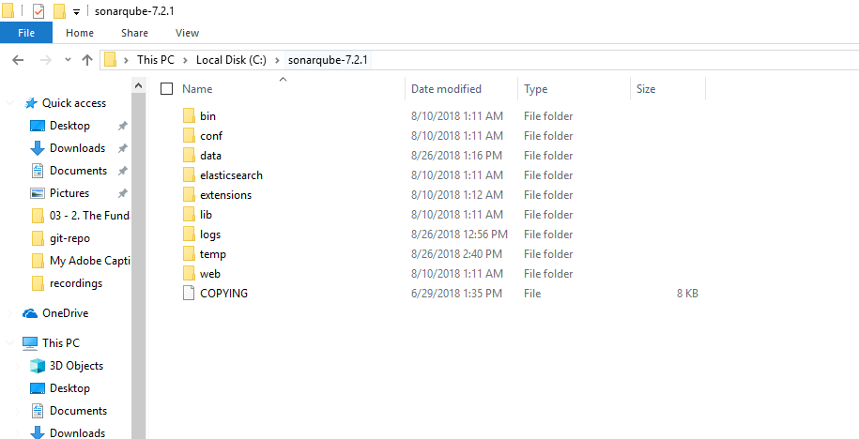

Step 2 : Create a database in SQL Server 2016 with collation SQL_Latin1_General_CP1_CS_AS.

(I have created database with name of SonarDB)

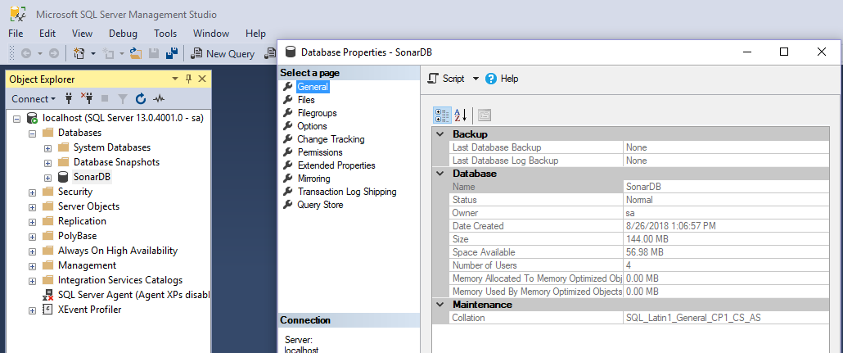

Step 3 : Download sql server jdbc driver from below URL and extract the files. Copy the sqljdbc_auth.dll and paste into the folder “c:\windows\system32\”

Link : <https://www.microsoft.com/en-us/download/details.aspx?id=57175>



Step 4 : Open the sonar.properties from your sonarqube extracted directory inside conf folder. And do the below changes based on your settings

I have used database with sql mixed mode credential. So I have uncommeted the username and password and filled with required value. And same below sonar.jdbc.url is uncommented and I given my database name.

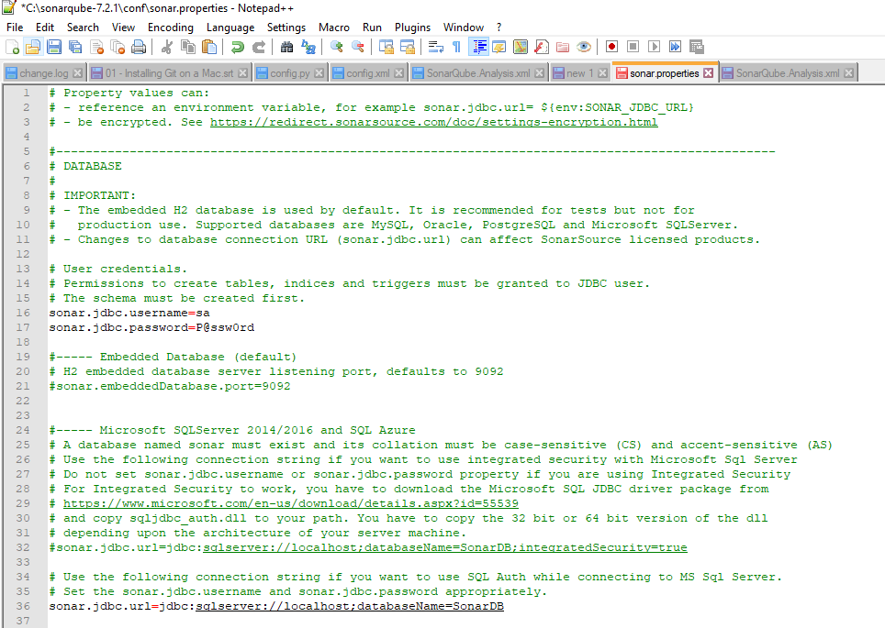

Step 5 : Restart your sonarqube instance in windows services and restart the service.

To reach services goto run -> services.msc and hit ok.

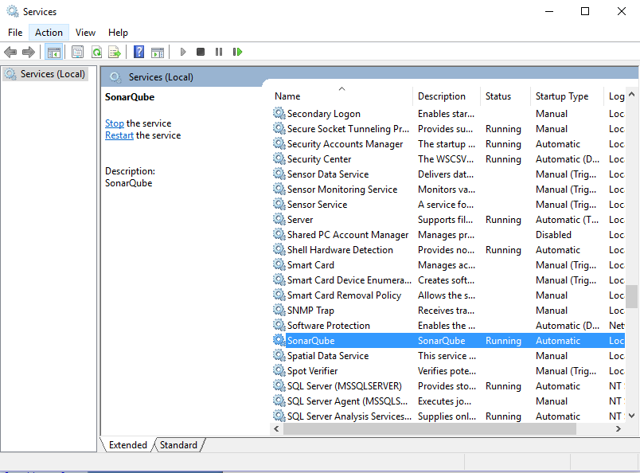

Step 6 : Finally you can browse localhost:9000 and you can able to see the sonarqube page.

